Portfolio Optimization Results
Student Name: Sergiy Palguyev
GT User ID: spalguyev3
GT ID: 903272028
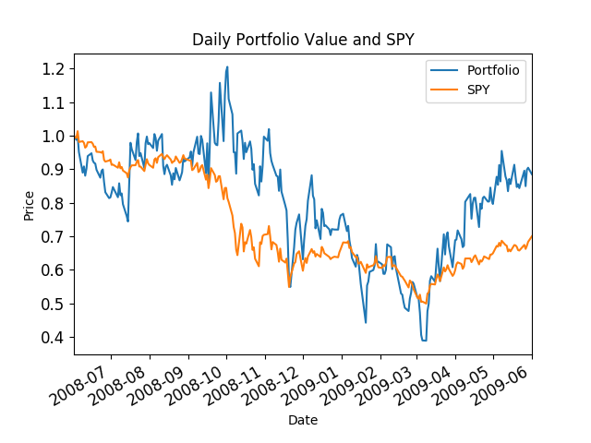
Figure 1: Portfolio vs SPY
Default Allocations [0.25, 0.25, 0.25, 0.25]
Start Date: 2008-06-01 00:00:00
End Date: 2009-06-01 00:00:00
Symbols: ['IBM', 'X', 'GLD', 'JPM']
Allocations: [ 5.55111512e-17 0.00000000e+00 2.77555756e-17 1.00000000e+00]
Sharpe Ratio: 0.423107179242
Volatility (stdev of daily returns): 0.0689110688493
Average Daily Return: 0.0018367037394
Cumulative Return: -0.114809081527

